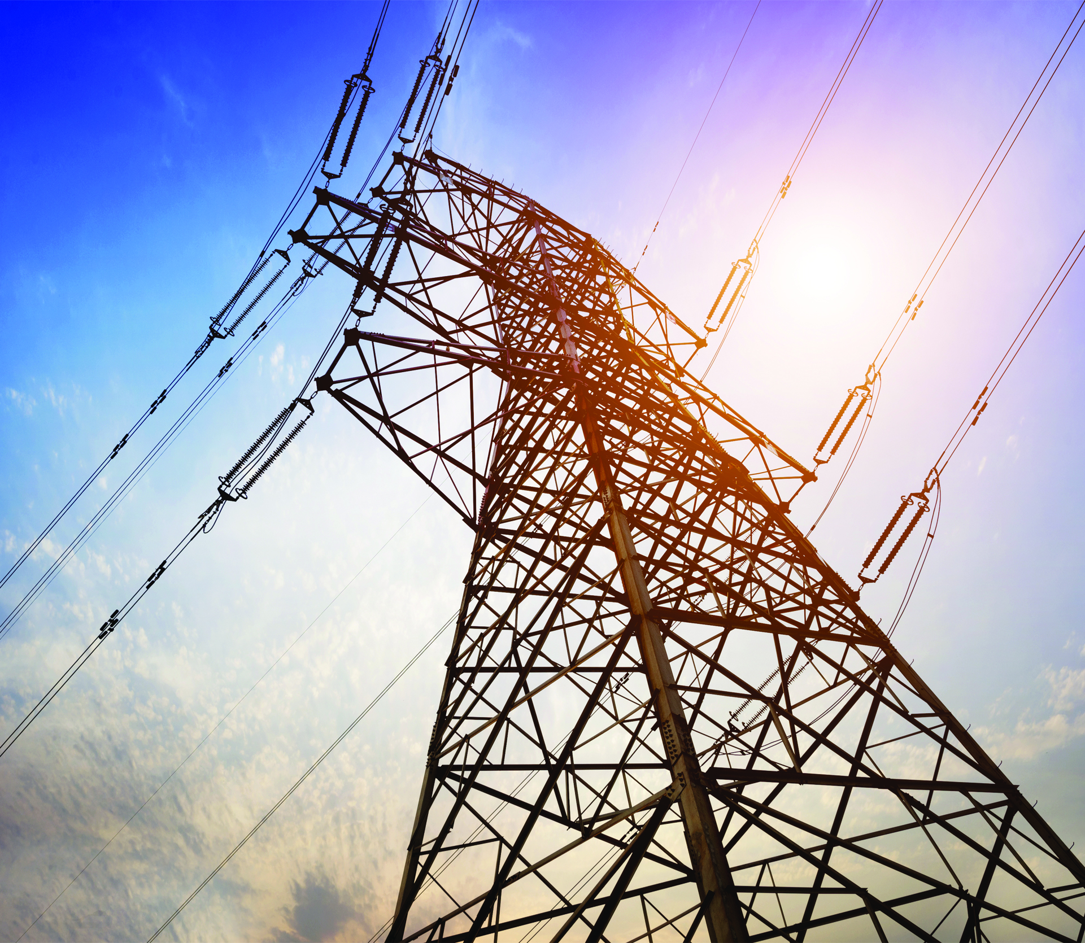

**POWER SYSTEMS PROJECT**

**Prepared by: Group (8)**

**Ziad Ayman Anwar Sayed**

**Ziad Hamdy Mohamed**

**Ziad Samy Mohamed Fathy Ramadan**

**Ziad Sayed Ahmed**

**Ziad Emad Abdel-Ghaffar Mostafa**

**Ziad Amr Sayed Ahmed**

**Ziad Mohamed Abdel-Hamid**

**Ziad Medhat Aboul-Atta Ali**

**Submitted by : Dr. Heba Ahmed**

**Eng. Hussein mahmoud**

Table of Contents

1) Abstract 3

2) Introduction 3

3) Code Explanation 5

4) Purposes and Results of the Project 6

5) Conclusion for Transmission Line Analysis and Optimization Project 10

6) Project Impact 11

7) Conclusion 11

8) References 11

# **1) Abstract**

# ****Advanced Transmission Line Analysis and Compensation Report****

# ****Advanced Transmission Line Analysis and Compensation Report****

* This project introduces a computational program developed for the detailed analysis of AC electric transmission lines.
* The program aims to evaluate the electrical characteristics of transmission lines to support efficient, stable, and reliable power delivery.
* It provides analytical insight into transmission line behavior under different operating and loading conditions, which is essential for proper system design and optimization.
* The software calculates fundamental transmission line parameters, including resistance, inductance, and capacitance per unit length.
* Generalized ABCD constants are derived to model the electrical relationship between the sending end and receiving end of the line.
* The analysis covers short and medium transmission lines, with medium lines represented using both Π (Pi) and T equivalent circuit models.
* User-defined inputs such as operating frequency, line voltage, transmitted power, power factor, transmission line length, and conductor geometry are incorporated into the calculations.
* A series compensation model inspired by Thyristor Controlled Series Capacitor (TCSC) operation is integrated into the program.
* The compensation model allows the user to specify a target compensation level for the transmission line.
* Based on the selected compensation level, the program determines the optimal number of thyristor-controlled stages that should be in the conducting or blocking state.
* This adaptive control strategy contributes to improved voltage regulation and enhanced power transfer capability.
* The computational approach is based on fundamental power system principles, including per-unit-length reactance modeling and generalized reactance analysis.
* Iterative calculation techniques are applied to ensure accurate results and optimal compensation configurations.
* The developed tool serves both educational and practical purposes, supporting transmission line analysis, performance evaluation, and preliminary power system design.

# **2) Introduction**

### **2.1 Background on Transmission Lines in Power Systems**

Transmission lines form the backbone of modern electrical power systems, enabling the transfer of large amounts of electrical energy from generation plants to load centers over long distances. Their design, modeling, and operational performance play a crucial role in determining the overall reliability, efficiency, and stability of power networks.

From an electrical perspective, transmission lines are characterized by distributed parameters such as resistance, inductance, and capacitance. These parameters directly influence:

* Power losses along the line
* Voltage drop and voltage regulation
* Reactive power flow
* System stability under steady-state and dynamic conditions

Accurate modeling of transmission lines requires the determination of their per-unit-length electrical parameters, followed by the formulation of suitable equivalent circuit models. One of the most widely used analytical representations is the generalized ABCD parameter model, which establishes a mathematical relationship between sending-end and receiving-end voltages and currents.

The ABCD constants provide a systematic method for:

* Analyzing power flow characteristics
* Evaluating voltage regulation
* Studying the impact of loading conditions
* Assessing system performance under different operating scenarios

Proper transmission line design also involves effective control of voltage levels and reactive power. Inadequate reactive power management can lead to excessive losses, poor voltage profiles, and reduced power transfer capability. Therefore, accurate transmission line modeling and compensation techniques are essential for maintaining stable, efficient, and reliable power system operation.

### **2.2 Objectives of the Project**

The primary objective of this project is to develop a computational software tool capable of analyzing and simulating the electrical behavior of transmission lines under various operating conditions. The specific goals of the project include:

* **Transmission Line Modeling**
  + Accurately model short, medium, and long transmission lines based on their physical length and electrical characteristics.
  + Evaluate key parameters such as resistance, inductance, capacitance, and impedance.
* **Performance Analysis**
  + Analyze power flow, voltage regulation, and current distribution along the transmission line.
  + Study the effect of line length and loading conditions on system performance.
* **Compensation and Control Evaluation**
  + Investigate different compensation techniques for reactive power control.
  + Assess their impact on improving voltage stability and power transfer capability.
* **User-Driven Simulation**
  + Allow user-defined inputs such as voltage level, power factor, frequency, and conductor properties.
  + Provide flexible and realistic simulations that reflect practical power system scenarios.

# **3) Code Explanation**

This program simulates the electrical behavior of transmission lines (TL) and calculates essential parameters for both medium and short lines. It is designed to help engineers and students analyze transmission line performance and optimize power system design.

**1. Purpose**

* Simulate the electrical behavior of transmission lines.
* Calculate key characteristics including impedance, admittance, and ABCD constants.
* Support analysis for both medium and short transmission lines.

**2. Initial Inputs**

1. A close-up of a computer code

   AI-generated content may be incorrect.A screenshot of a computer program

   AI-generated content may be incorrect.**Operating Conditions:** Users enter the operating frequency, phase-to-phase voltage, active power, power factor, and indicate whether the power factor is leading or lagging. The program then calculates complex power (S) and reactive power.
2. **Transmission Line Length:** Users input the transmission line length (tr2), which must be between 0 and 240 km. Out-of-range values prompt a re-entry.
3. **Material and Physical Properties:** Based on line length and ambient temperature, the program calculates the resistivity of the conductor material (aluminum) and adjusts for skin effect and spiraling factor.
4. **Line Configuration:** Users select either a single-phase or three-phase line. The program computes the geometric mean distance (GMDeq) based on the configuration and conductor spacing.
5. **Conductor and Strand Details:** Users provide the number of conductors per phase, conductor radius, bundle spacing, and strand radius. The program calculates the geometric mean radius (GMR) from these inputs.

**3. Transmission Line Parameter Calculations**

1. **Line Impedance and Admittance:** The program calculates the line’s resistance (R), inductance (L), and capacitance (C) based on the selected configuration.
2. **Current and Power Calculations:** Line current is determined using the conjugate of the complex power (S), and impedance and admittance are computed using line length and material properties.
3. **Transmission Line Model:** Users choose between the PI model or T model. The program calculates the corresponding ABCD constants (A, B, C, D) depending on the chosen model.

**4. Outputs**

* The program displays the sending-end voltage (Vs), including its magnitude and phase angle.
* ABCD constants for the selected transmission line model are provided for further analysis.

# **4) Purposes and Results of the Project**

**4.1 Purpose**  
The primary goal of this project is to develop a computational tool that assists in the analysis, design, and optimization of electrical transmission lines. By implementing algorithms to calculate key parameters such as resistance, inductance, capacitance, and ABCD constants, the software enables engineers to evaluate transmission line performance efficiently and accurately. The project also simulates the impact of various compensation techniques on power transfer and voltage stability, facilitating informed design decisions.

**Key Objectives:**

1. **Accurate Parameter Estimation:**
   * Provide reliable calculations for transmission line characteristics under different configurations.
2. **Simulation of Real-World Scenarios:**
   * Model short, medium, and compensated transmission lines to study their behavior in practical conditions.
3. **Optimization:**
   * Determine the optimal configuration for compensation stages to achieve maximum power transfer efficiency.
4. **User-Centric Design:**
   * Present results in an easy-to-understand format, including tables, graphs, and numerical outputs.

**4.2 Significance**

1. **Enhancing Engineering Efficiency:**
   * Reduces manual effort and errors, saving time in design and analysis.
   * Automates complex calculations, ensuring consistency and accuracy.
2. **Improving Transmission Line Design:**
   * Enables analysis and optimization for minimal losses, stable voltage regulation, and maximum power transfer.
3. **Impact of Compensation Techniques:**
   * Demonstrates the effect of reactive power compensation in reducing effective reactance and enhancing power delivery.
   * Provides insights for selecting the optimal configuration of compensation stages.
4. **Educational Tool:**
   * Serves as a valuable resource for students and professionals to understand both theoretical and practical aspects.
5. **Cost-Effectiveness:**
   * Efficient designs reduce power losses, contributing to project cost savings.
6. **Environmental Benefits:**
   * Optimized transmission line designs reduce energy losses, lowering emissions from power generation.

**4.3 Results**

**Example Input Parameters:**

1. **Transmission Line Parameters:**
   * Operating frequency: 50 Hz
   * Phase-to-phase voltage: 220 kV
   * Active power: 150 MW
   * Power factor: 0.9 lagging
   * Transmission line length: 150 km (Medium TL, PI model)
2. **Line Configuration:**
   * Ambient temperature (T2): 30°C
   * Spiraling factor (Sp): 0.02
   * Skin effect factor (Sk): 0.01
   * T1 = 25°C
   * Resistivity of Aluminum (ρT1) = 1.72×10⁻⁸ Ω·m
   * Temperature constant (T) = 228°C
   * Phase type: 3-phase
   * Distances between phases: Dab = 4 m, Dbc = 4 m, Dca = 4 m
3. **Bundle Configuration:**
   * Number of conductors per phase (Nb): 2
   * Conductor radius (rb): 1.5 cm
   * Distance between bundles (s): 40 cm
   * Number of strands (Ns): 6
   * Radius of strand (rs): 0.5 cm
4. **Compensation Parameters:**
   * Short and lossless TL
   * Maximum power (Pmax): 418 MW
   * Sending-end voltage (Vs): 218 kV
   * Receiving-end voltage (Vr): 237 kV
   * The maximum Vs : 230 KV
   * Capacitance reactance per stage: 12 Ω
   * Inductive reactance per stage: 1.71 Ω
   * Series inductive reactance: 54 Ω
   * Number of stages: 4
   * Power angle (PA): 15°

**4.3.1 Manual (Theoretical) Calculations**

* **Resistance:**
  + A close up of a sign

    AI-generated content may be incorrect.ρT2 = 1.75399×10⁻⁸ Ω·m
  + RdcT2 = (ρT2 / (π·rs²·Ns·Nb))·(1 + Sp) × 10³ = 0.018982 Ω/km
  + RacT2 = RdcT2·(1 + Sk) = 0.019172 Ω/km
* **Inductance:**
 $GMD =\sqrt[3]{Dab·Dbc·Dca } = 4 m$

 + GMR = rb·e⁻⁰.²⁵·s·10⁻² = 0.06836 m
  + L = 2×10⁻⁷·ln(GMD/GMR)·10³ = 0.00081385 H/km
* **Capacitance:**
  + GMR = rb·s·10⁻² = 0.07746 m
  + C = (2·π·ε₀ / ln(GMD/GMR))·10³ = 1.410428×10⁻⁸ F/km
* **Generalized Circuit Constants:**
  + Z = (RacT2 + j·2·π·f·L)·Length = 2.8758 + 38.35178 j Ω
  + Y = j·2·π·f·C·Length = 6.64649×10⁻⁴ j S
  + A = 1 + (Z·Y / 2) = 0.98725 + 0.0009557 j
  + B = Z = 2.8758 + 38.35178 j Ω
  + C = Y·(1 + (Z·Y / 4)) = -3.17602×10⁻⁷ + 6.60041×10⁻⁴ j S
  + D = 1 + (Z·Y / 2) = 0.98725 + 0.0009557 j
* **4.3.2 Software vs. Theoretical Comparison**

|  |  |  |  |
| --- | --- | --- | --- |
| Parameter | Theoretical | MATLAB | Error |
| Resistance | 0.019171 Ω/Km | 0.019172 Ω/Km | 0.005% |
| Inductance | 0.00081385 H/km | 0.00081386 H/km | 0.0012% |
| Capacitance | 1.410428×10⁻⁸ F/km | 1.4098×10⁻⁸ F/km | 0.0445% |
| A | 0.98725 + 0.0009557 j | 0.98726 + 0.00095529 j | 0.001% |
| B | 2.8758 + 38.35178 j | 2.87587 + 38.3522 j | 0.0012% |
| C | -3.17602×10⁻⁷ + 6.60041×10⁻⁴ j | -3.1732×10⁻⁷ + 0.00066012 j | 0.012% |
| D | 0.98725 + 0.0009557 j | 0.98726 + 0.00095529 j | 0.001% |

**Conclusion from Comparison:**  
The calculated values closely align with theoretical expectations, with minor variations (<0.05%) due to rounding.

**4.3.3 Series Capacitor Compensation (User-Optional Feature)**

* Xeff = (Vr·Vs·sin(PA)) / Pmax = 32 Ω
* Number of closed stages = 2, Number of open stages = 2
* Total reactance = 34 Ω
* Actual transmitted power = 393 MW

|  |  |  |  |
| --- | --- | --- | --- |
| Parameter | Theoretical | MATLAB | Error |
| Xeff | 32 Ω | 31.99 Ω | 0.03% |
| Closed stages | 2 | 2 | 0% |
| Open stages | 2 | 2 | 0% |
| Total reactance | 34 Ω | 33.99 Ω | 0.029% |
| Actual power | 393 MW | 393.43 MW | 0.11% |

**4.4 Advantages of the Software**

1. **Efficiency:**
   * The software automates complex calculations involved in transmission line analysis, significantly reducing manual effort and minimizing the possibility of human error.
   * It allows engineers to perform repeated calculations for multiple scenarios quickly, improving productivity and reducing design time.
2. **Versatility:**
   * The tool supports different types of transmission lines, including short and medium lengths, and accommodates both PI and T models.
   * It is capable of handling various line configurations, conductor types, and compensation stages, making it adaptable for multiple power system studies.
3. **Customization:**
   * Users can input a wide range of parameters, such as the number of phases, conductor properties, environmental conditions (temperature, skin effect, spiraling factor), and bundle configurations.
   * This flexibility ensures realistic simulations that reflect real-world conditions for engineering analysis.
4. **Optimization Insights:**
   * The software helps identify optimal configurations for maximum power transfer with minimal reactance.
   * By simulating compensation strategies, it provides insights into how to enhance voltage stability, reduce losses, and improve overall transmission efficiency.
5. **User-Friendly Output:**
   * Results are presented clearly in tables and numerical formats, showing important metrics such as power transfer, effective reactance (Xeff), and voltage regulation.
   * Graphical representations of voltage, current, and compensation effects make it easier to interpret the results for both engineers and students.

**4.5 Suggestions for Improvement**

1. **Expand Model Coverage:**
   * Include long transmission lines with distributed parameters for a complete analysis framework.
   * Add support for High Voltage Direct Current (HVDC) transmission systems.
2. **Graphical User Interface (GUI):**
   * Develop an intuitive GUI to simplify parameter input and enhance visualization of simulation outputs.
   * A GUI would also improve usability for students and engineers with limited programming experience.
3. **Integration of Real-World Data:**
   * Allow incorporation of geographic and layout data for actual transmission line routes.
   * This would enable more accurate simulations that account for real-world constraints and conditions.
4. **Advanced Analysis Tools:**
   * Include features for fault analysis, stability studies, and harmonic analysis to assess power quality issues.
   * Implement dynamic simulation capabilities for transient conditions.
5. **Optimization Techniques:**
   * Automate compensation stage configuration using optimization algorithms, such as genetic algorithms or machine learning, to identify optimal setups.
6. **Export Capabilities:**
   * Provide options to export results and graphs in multiple formats (e.g., CSV, PDF) for reporting, documentation, and presentations.
7. **Time-Domain Simulation:**
   * Introduce simulation of transient behavior over time to study dynamic responses of transmission lines under disturbances.

# **5) Conclusion for Transmission Line Analysis and Optimization Project**

1. **Accurate Classification:**
   * The program effectively classifies transmission lines into short, medium, and long categories based on their length.
   * Appropriate mathematical models are applied for each type, ensuring accurate analysis.
2. **Parameter Estimation:**
   * Calculates resistance, inductance, and capacitance per unit length using conductor and environmental properties.
   * Ensures realistic and reliable results that closely match theoretical expectations.
3. **ABCD Constants Calculation:**
   * Derives ABCD constants for short and medium transmission lines, supporting detailed power flow and voltage regulation studies.
4. **Power Flow Optimization:**
   * Integrates series and shunt compensation strategies to optimize effective reactance.
   * Enables maximum power transfer while maintaining system stability and minimizing losses.
5. **Flexibility:**
   * Supports single-phase and three-phase systems, bundled conductors, and various line configurations.
   * Capable of adapting to different engineering scenarios and transmission line designs.
6. **Practical Applications:**
   * Facilitates determination of maximum transferable power and optimal compensation configurations.
   * Provides insights into the effects of line length, environmental factors, and operating conditions on performance.
7. **User Interaction:**
   * Features an interactive interface for easy input of system parameters.
   * Accessible to both students and engineers for educational and practical purposes.

# **6) Project Impact**

* The project provides a comprehensive and practical tool for power system engineers to design, evaluate, and optimize transmission lines.
* It demonstrates how transmission line characteristics influence overall system performance, and highlights the benefits of compensation techniques in enhancing power delivery and voltage stability.
* By automating calculations and supporting multiple line configurations, the software contributes to improved efficiency, cost-effectiveness, and environmental sustainability in power transmission projects.

# **7) Conclusion**

* The project successfully developed a software tool capable of comprehensive analysis of transmission line parameters and evaluation of Thyristor Controlled Series Capacitor (TCSC) compensation.
* It accurately computes resistance, inductance, and capacitance for user-defined inputs, and derives ABCD constants that model the transmission line’s electrical behavior.
* The integration of the TCSC model allows dynamic control of compensation by adjusting thyristor firing angles.
* The software determines the optimal number of closed and open thyristor stages to achieve the desired level of compensation, ensuring efficient power transfer and stable voltage regulation.
* Overall, the project provides a robust platform for both educational and professional applications, offering detailed insights into transmission line design, performance analysis, and optimization strategies.

# **8) References**

1. Grainger, J.J., & Stevenson, W.D. Power System Analysis. [PDF link](https://ritwikchowdhury.wordpress.com/wp-content/uploads/2017/12/power_system_analysis_john_grainger_1st.pdf)
2. IEEE Guide for Overhead AC Transmission Line Design (IEEE Std 1863-2019). [Link](https://ieeexplore.ieee.org/document/9086170?utm_source=chatgpt.com)
3. Wildi, T. Electrical Machines, Drives and Power Systems, Pearson Education Inc., Sixth Edition, 2006.